**Minutes of the seminar of the NEOLAiA HRS4R Team**

**November 26-27, 2024, university of Tours**

# Attendees

*The following list only includes the attendees of the seminar of the NEOLAiA HRS4R team. The WP5 days of November 26-28, 2024, university of Tours also hosted all the WP5 delegates, members of the Task 5.5. Living Lab Hub.*

**Örebro university:**

Pia Bro-Nygårdhs, NEOLAiA Project Manager

Magnus Kristoffersson, WP5 leader

Martina Liljerås, HR coordinator, Human Resources Department

Linus Mattisson, marketing officer, Communication and Collaboration Office

Erwin van Rijswoud, Quality coordinator, Faculty Office

**University of Tours:**

Céline Bodin, HRS4R project manager

Jérôme Casas, professor of ecology and former HRS4R project leader

Frédéric Matyjas, HRS4R project manager

Clément Peinturier, Euraxess contact point and officer, International Relationships Department

Clémentine Périnaud, Task WP5-3 leader, NEOLAiA Office

**University of Jaén:**

Emilio Muñoz Cerón, head of R&I International project Office

**University of Ostrava:**

Lucie Holubová, Head of the Centre for HR Management

Jana Pajak, Head of the Human Resources Department

**University of Nicosia:**

Elisa Bosio, WP5 co-delegate, Head of Rankings Administration, Research and Innovation Office

Despo Ierodiakonou, WP5 co-delegate, associate dean for research, faculty of medecine

Natalia Neokleous, administrator, Research and Innovation Office

Stella Manoli, head of the Research and Innovation Office

**Stefan cel Mare University of Suceava:**

Otilia Cramariuc, representative of Euraxess network

Aurelian Rotaru, vice rector for research activities

**University of Salerno:**

Tiziana Bisogno, project manager, Teaching staff recruitment office

Sarah Pellone, WP5 co-delegate, research fellow

Vittorio Scarano, WP5 delegate, professor of computer sciences

Tiziana Varani, project manager, Teaching staff recruitment office

**Šiauliai State University of Applied Sciences:**

Nedas Jurgaitis, WP5 delegate, Deputy Director of Šiauliai State University of Applied Sciences

*The organisation of the seminar of the NEOLAiA HRS4R team and the WP5 days was allowed with the involvement of the NEOLAiA office of the university of Tours (Claire Durand, WP4 delegate – Hanan El khadir, WP2 co-leader - Lindsay Georges, WP6 delegate), NEOLAiA student ambassador, Amandine Deloustal, and two students CERCIP, Albane Munez and Angèle Gastrin.*

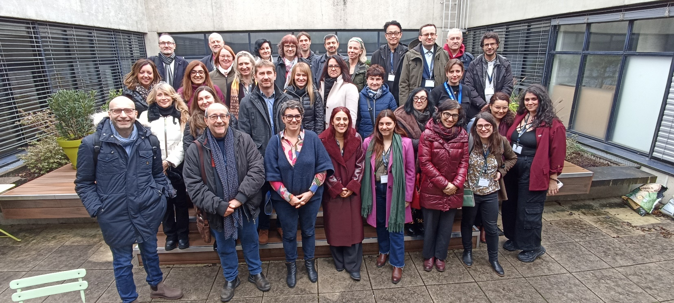

# November 26, 2024 programme

***Location: Faculty of Law, Economics and Social Sciences – University of Tours, 50 avenue Jean Portalis, Tours***

**8:30 – 9:00 – Coffee and registration**

Room: in front of the “Salle du Conseil”, building B, 2nd floor

**9:00 – 9:30 – Welcome remarks and introduction to the WP5 days**

Room: Salle du Conseil, building B, 2nd floor

With: Åke Strid, Pro-vice Chancellor, International and Infrastructure (ORU) and Colombine Madelaine, Vice President for International Affairs (UT)

**9:30 – 10:15 – Supporting Scientific Research in European Alliances of Universities: a keynote**

Room: Salle du Conseil, building B, 2nd floor

With: Ludovic Thilly Vice-Rector for EC2U Alliance and European Networks at the University of Poitiers, Coordinator General of the EC2U Alliance, Co-Coordinator of FOR-EU4ALL

**Short summary of the session:** The presentation outlined the key activities to support research and foster research collaborations of the European Campus of City-Univerisities, the EC2U alliance that gathers seven universities (expanding to nine): Mapping of research synergies (pilot phase), Establishment of three virtual institutes focusing on UN Sustainable Development Goals (2020-2023), launch of three related joint master’s programs, financing of PhD thesis, support for mobilities (over 2 700 mobilities, students and staff). The consolidation phase of the alliance (2023-2027) aims to increase the number of partners, associate partners and virtual institutes.

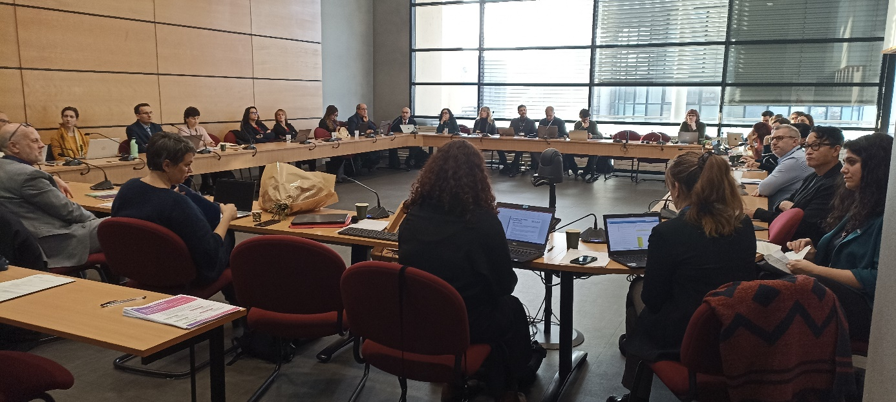

*Coffee break*

**10:30 – 12:10 – workshop session 1 of the NEOLAiA HRS4R team: mentoring programmes and career development**

Room: A206

With an introduction by Jérôme Casas, professor of ecology, former HRS4R project leader, 2017-2024 (UT)

**Short summary of the session:** During the introductory session, Professor Jérôme Casas outlined the challenges and benefits of mentoring for early-career teacher-researchers, emphasizing the importance of providing each individual with the opportunity to pursue long-term, high-quality, and internationally connected research. The presentation also introduced various mentoring models in use across Europe and the United States. Three NEOLAiA universities (UT, ORU, USV) then presented the actions they have implemented to support one of the four pillars of the HRS4R framework. These examples provided an opportunity to offer practical and concrete insights into the steps involved in defining and implementing HRS4R actions. The session concluded with a debate on the challenges of providing administrative support for researchers' career development, which is significantly shaped by the existing national frameworks.

**To know more about mentoring programme, here is an access to a dedicated two-days seminar (UT)**:

https://www.univ-tours.fr/recherche/hrs4r/mentoring-conference-for-newly-appointed-teachers-and-researchers

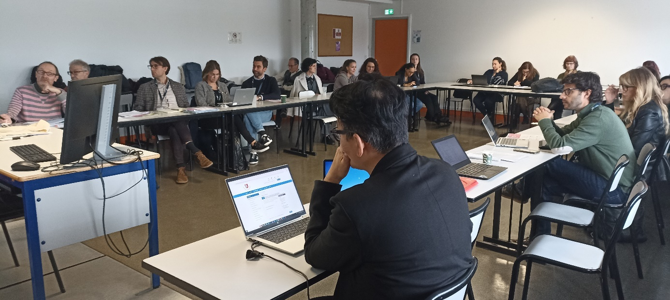

**12:10 – 12:30 – Presentation of the NEOLAiA *Virtual Cafe***

Room: A206

With Vittorio Scarano, WP5 delegate, leader of the WP8 Open science and task 10.3. leader (UNISA)

**Short summary of the session:** The Virtual Café is a social network developed by the partners of the university of Salerno that can be used by the NEOLAiA HRS4R Team for internal communication and support NEOLAiA partners.

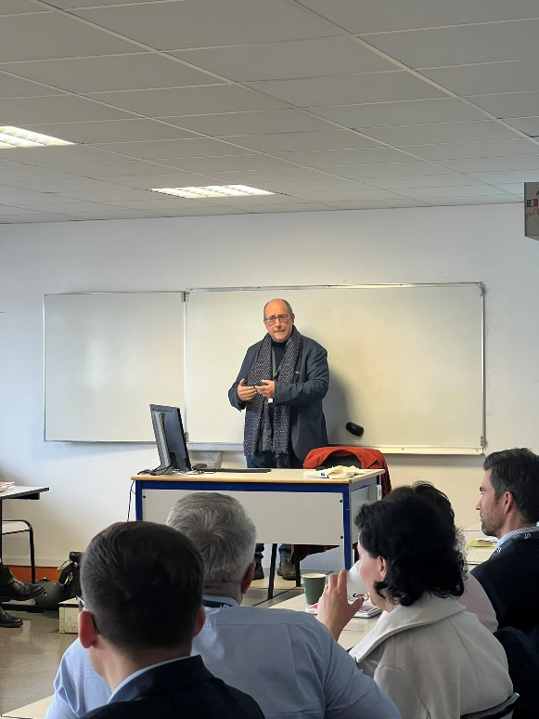 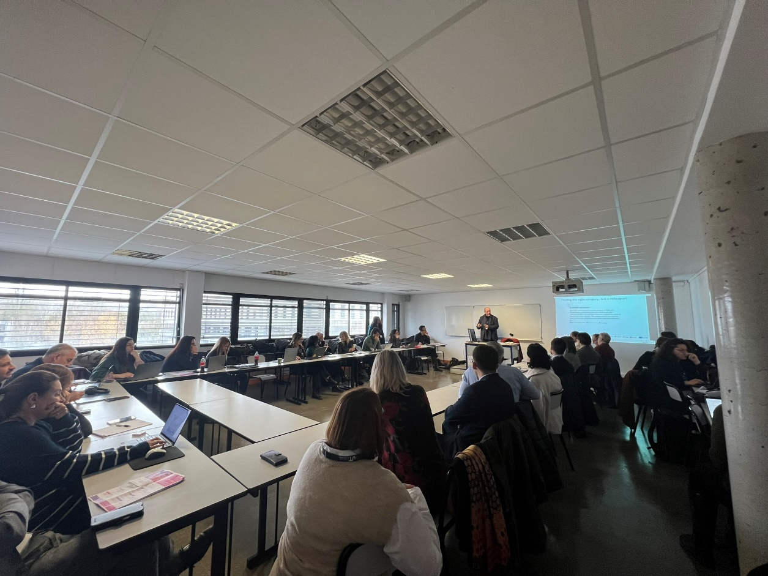

*Lunch break*

**14:00 – 15:30 – workshop session 2 of the NEOLAiA HRS4R team: Communicating internally and externally**

Room: A207

Led by Martina Liljeras, HR coordinator (ORU), Erwin Van-Rijswoud, quality manager (ORU) and Linus Mattisson, marketing officer (ORU)

**Short summary of the session:** Following a presentation of the internal and external communication strategies employed by Örebro University to promote the principles of the European Charter for Researchers and the Code of Conduct for the Recruitment of Researchers, the members of the NEOLAiA HRS4R team were invited to work in small groups on their communication strategies. They discussed the communication approaches used at each university, highlighting differences based on target audiences and evaluating the value of these communication efforts. They finally work on the way to cooperate within the NEOLAiA network.

**Link to the ORU video:** <https://www.oru.se/english/career/the-human-resources-strategy-for-researchers-hrs4r/>

**Link to the paddlet:** <https://padlet.com/HRS4R/how-do-we-effectively-communicate-on-hrs4r-urwb9wfawy0fj3ah>

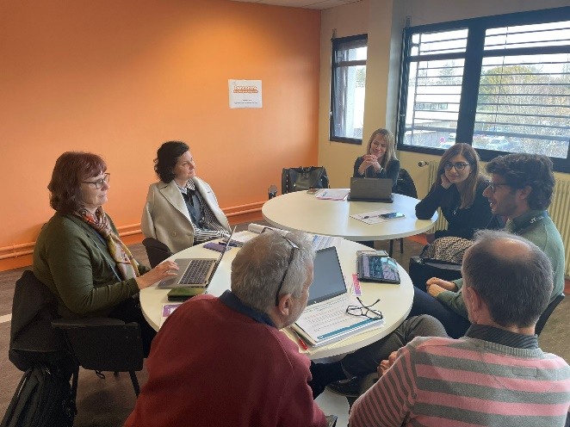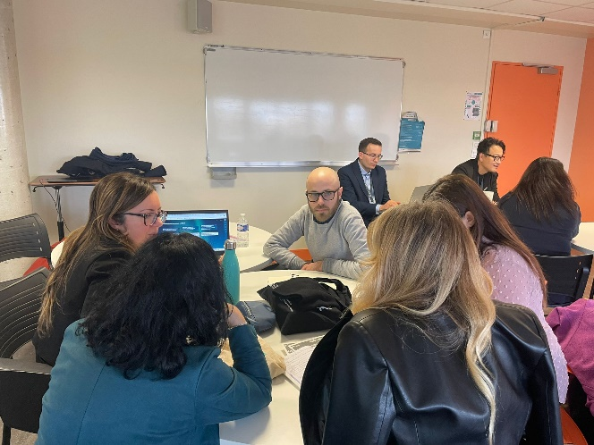

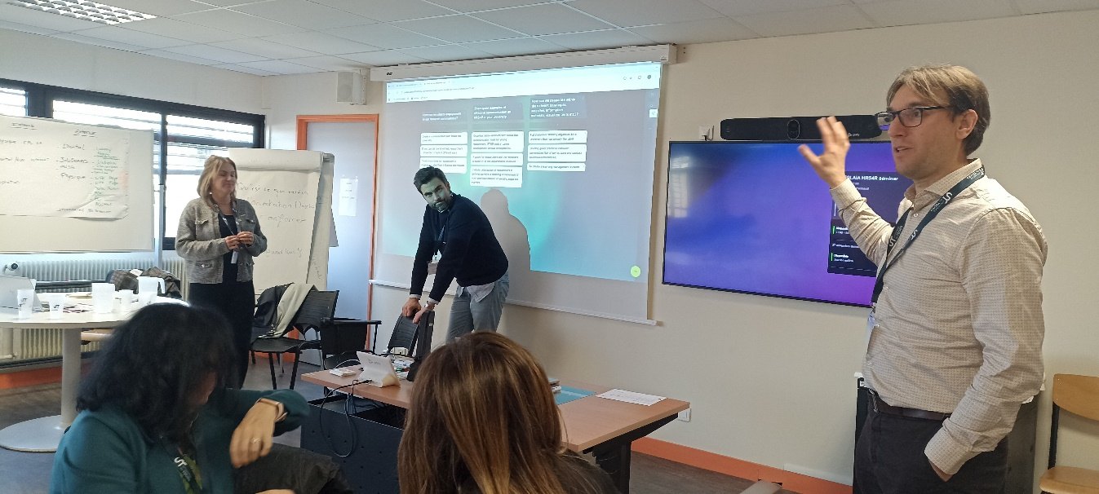

**15:45 – 16:30 – workshop session 3 of the NEOLAiA HRS4R team: monitoring progress and build indicators**

Room: A207

Presented by Frédéric Matyjas, HRS4R project manager (UT)

**Short summary of the session:** During this session, the management tools used for the HRS4R plan at the Universities of Tours and Örebro were presented in detail, highlighting both the strengths and limitations of each approach. Additionally, related monitoring indicators for each action were introduced, emphasizing their diversity and complementarity.

*Guided visit of the city of Tours (17:00-18:30) followed by an evening restaurant (19:30-21:00)*

# November 27, 2024 programme

***Location: Faculty of Law, Economics and Social Sciences – University of Tours, 50 avenue Jean Portalis, Tours***

**8:30 – 9:00 – Coffee and registration**

Room: in front of the “Salle du Conseil”, building B, 2nd floor

**9:00 – 9:30 – An introduction to the research at the university of Tours**

Room: Salle du Conseil, building B, 2nd floor

With Catherine Beaumont, vice-president for research (UT)

**9:30 – 11:30 - workshop session 4 of the NEOLAiA HRS4R team: The HR Excellence in Research Award: application and renewal**

Room: A214

With Isabelle Halleux, EU HRS4R Expert

Nathalie Modjeska, EU HRS4R Expert, head of the Support Service for Internationalisation and Attractiveness of Structural Projects, Department of Structural programs (University of Montpellier)

**Short summary of the session:** Isabelle Halleux provided an overview of the HR Excellence in Research award assessment cycle, offering guidance on how to identify the needs and priorities of researchers through GAP analysis, define the feasibility of initiatives with a 2-5 year plan, and ensure researchers' commitment to the GAP analysis and action plan. She also emphasized the importance of long-term stakeholder involvement. Finally, Isabelle introduced the updated charter, which now includes 20 principles organized into four pillars, outlining the requirements for new applicants and the associated implications.

Nathalie Modjeska provided an overview of a decade of implementing HRS4R policies across Europe and France, with a particular focus on the University of Montpellier. As the second institution in France to receive the HR Excellence in Research Award in 2015, she highlighted the key requirements for the award's renewal process and its various phases. She emphasized the importance of the EU on-site audits, which occur every six years, and discussed the need for careful planning, communication, preparation, and rehearsal in advance.

The presentations were followed by a moment of questions-answers focused on particular issues of each of the partners.

**Contacts:**

**Isabelle Halleux**, UE HRS4R Expert, [isabelle.halleux@uliege.be](mailto:isabelle.halleux@uliege.be)

**Nathalie Modjeska**, UE HRS4R Expert, [nathalie.modjeska@montpellier.fr](mailto:nathalie.modjeska@montpellier.fr)

**11:45 – 12:30 – workshop session 5 of the NEOLAiA HRS4R team: Defining an action programme for 2025-2027**

Room: A214

Led by Clémentine Périnaud, Task 5-3 leader, NEOLAiA office (UT)

**Short summary of the session:** To conclude the seminar, the NEOLAiA HRS4R Team outlined its next steps, focusing on two main objectives: (1) supporting partners in obtaining the HR Excellence in Research label by 2027, with clear steps, timelines, and regular reviews, and (2) providing guidelines to implement human resources strategies for researchers, including defining key themes and best practices. Remote meetings will be held every two months, with the next scheduled for January 27. Partners seeking the label found the process clearer after the seminar, with some already starting their GAP analysis. The team will create a database of key actions, gather HRS4R documentation, and facilitate discussions via virtual spaces. Key topics for future discussion include international welcoming, gender equality, and open science, with plans to align with other NEOLAiA working groups and develop joint actions.

**14:30 – 16:30 – Visit of the Campus of Sciences and Technology, Grandmont**

On-site visit of the university Library, the Institute of Research on Insect Biology, the Fac Lab of the campus

Led by Céline Bodin, NEOLAiA project manager (UT), Claire Durand, WP4 delegate, NEOLAiA office (UT) and Amandine Deloustal, NEOLAiA student ambassador (UT).

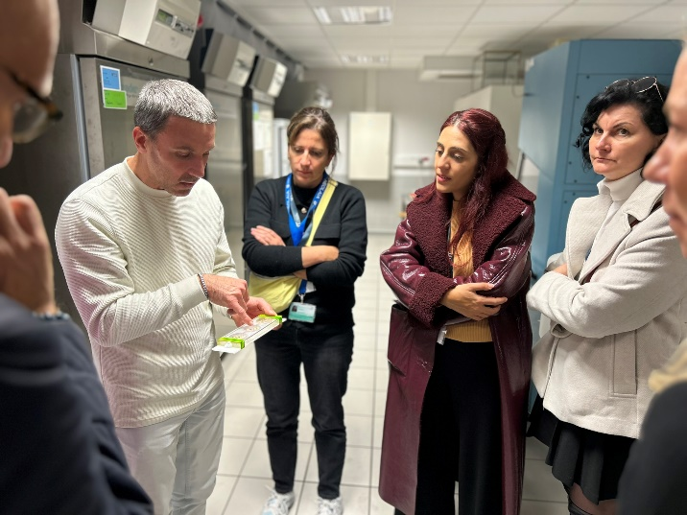 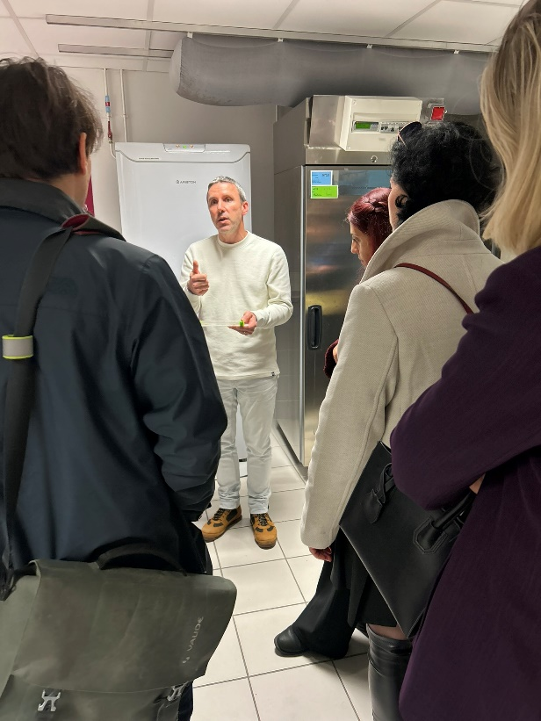

*18:45 – cocktail at the Villa Rebelais with a commented tasting of local products (****see all the picture of the event in ORU Teams!)***

